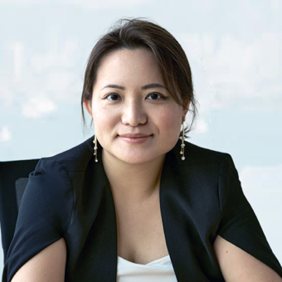
Larraine is also the founder of Ascension Associates, a business strategy and human capital management consultancy that brings strategy implementation, talent acquisition and human capital management together.

Having worked in the executive search field for over 8 years, Larraine often sees the alignment gap between business strategy and talent acquisition, and this prompts her to set up Ascension Associates to solve business problems with a bigger dimension.

She is leading the business development, marketing and international expansion, and continuing the mission to bridge the gap between strategy execution and organizational design for her clients.

Since 2020 Larraine has designed and delivered manager as a coach and various new people leader programs for financial services clients; as well as 1:1 coaching for aspiring entrepreneurs, department heads and C-suite executives. Starting from 2023 Ascension Associates has also been commissioned to work on employer branding projects and designed a bespoke learning journey for surgical sales teams of medical device company.

With her executive search background Larraine has also developed her own strategic talent acquisition framework, helping her clients to build employee value proposition, create company cultural statement, and facilitate internal communications mechanisms.

Prior to Ascension Associates, Larraine was the Recruitment Director for the Insurance Desk at a Hong Kong recruitment start-up at the time of 2011, and Life Actuarial Consultant for one of the fastest growing financial services search firms Gravitas Recruitment Group Asia.

A globe trotter who has studied and worked in Hong Kong, Calgary, London and California, Larraine is an avid reader, enjoys jazz, Impressionism art and practices yoga. She graduated from the University of Hong Kong in European Studies in 2009. She received her ICF (International Coaching Federation) credential in 2023 and is in preparation to be an endorsed facilitator by IAF. (International Association of Facilitators)

Certificates and Qualifications Received:
Leader Play Facilitator 2025
EMCC Accredited Practitioner 2025
ICF Associate Certified Coach 2023
OKR Practitioner by OKR International 2022
Scrum Master by Scrum Alliance 2022
Appreciative Inquiry Facilitator by Center of Appreciative Inquiry 2022
IECL Certified Team Coach 2020
Gallup Certified Strengths Coach 2019

Training Attended:
Association of Talent Development Training Design and Delivery; Creating Leadership Development Programs 2021
ICA UK Group Facilitation Methods, Participatory Strategic Planning 2023
ICA Taiwan Client Care and Design 2023
ICA Taiwan Transformative Action Planning 2025

